College MarketPlace

**NAME**-Aashish Bhardwaj

**ROLLNO**-2110990022

**SEMESTER**-5TH

**GROUP**-G5

**INSTRUCTOR**-Lavish Arora

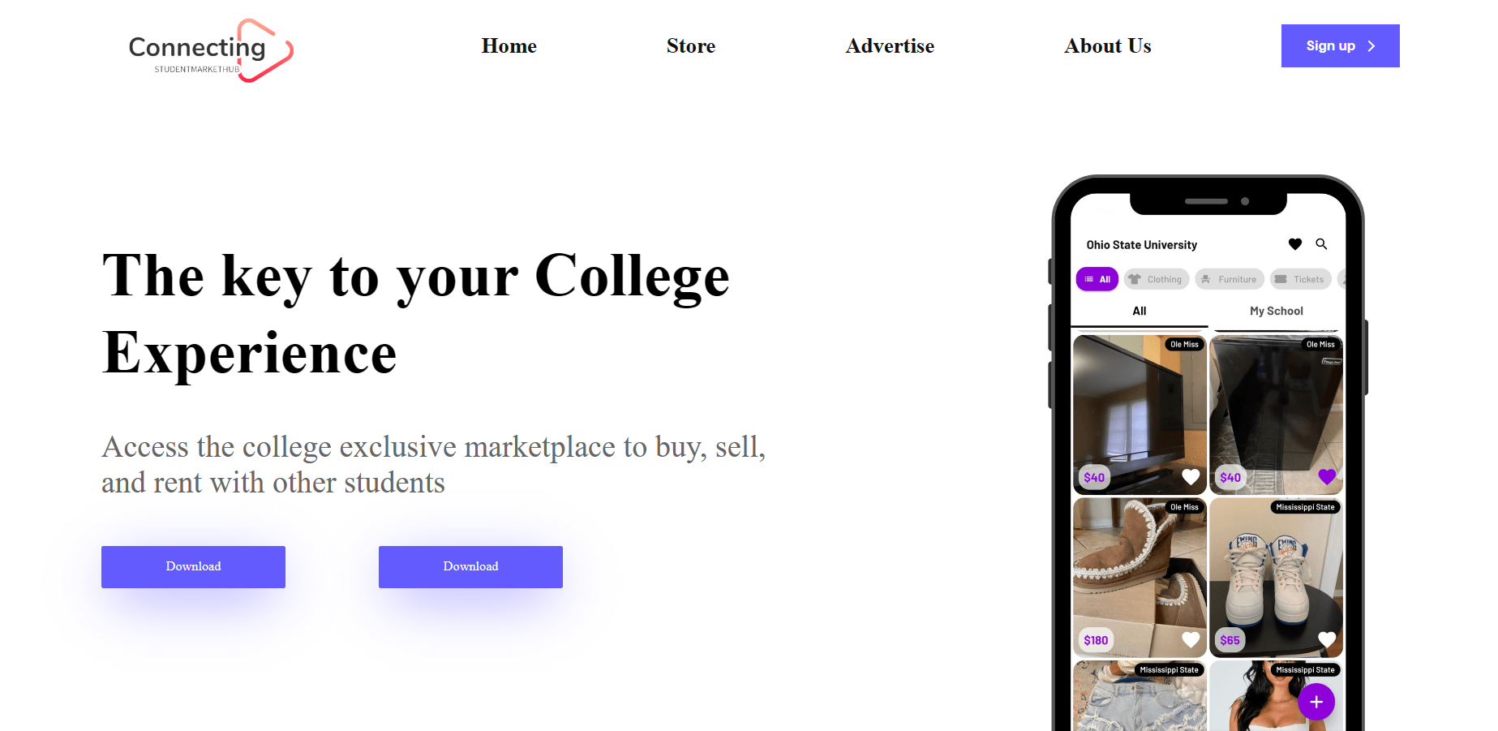

1. An engaging college marketplace website made with HTML, CSS, JavaScript, and Bootstrap. Experience seamless navigation with 10 pages including homepage, store, advertisement, contact us, and more.

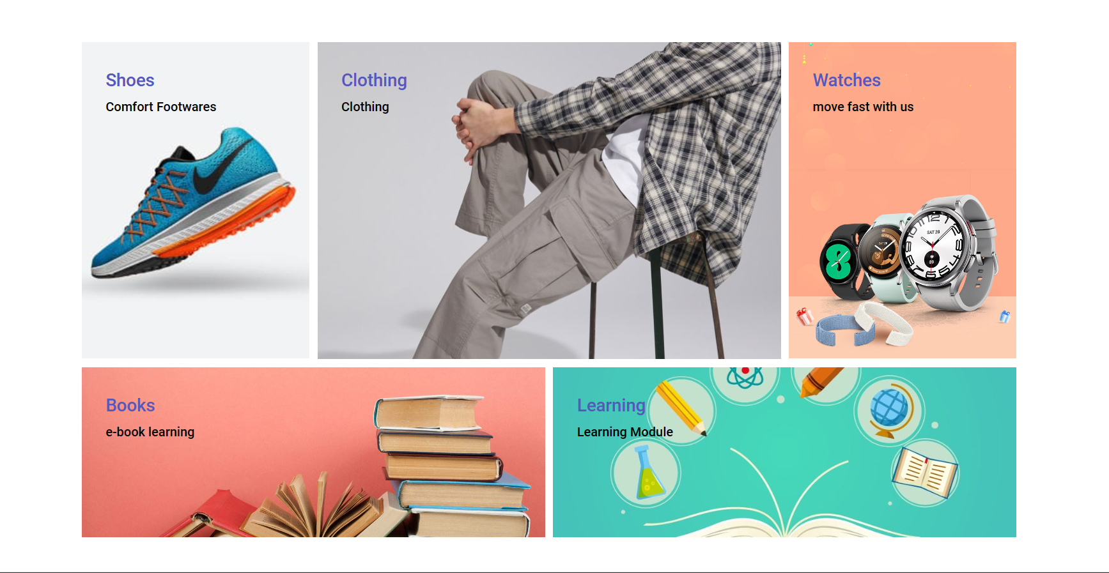

1. Facebook Marketplace and amazon are great but often times you have to drive a long way to meet up and pay for shipping . Student marketplace lets you know what is available at your college.
2. It is safer and easy to use.
3. We only sell and buy verified users.
4. 100% college audience which allows less or none scams.



3. **Store~You can buy and sell anything , For example-**

Clothing- Explore a trendy collection of clothing items for students, from stylish apparel to comfortable loungewear.

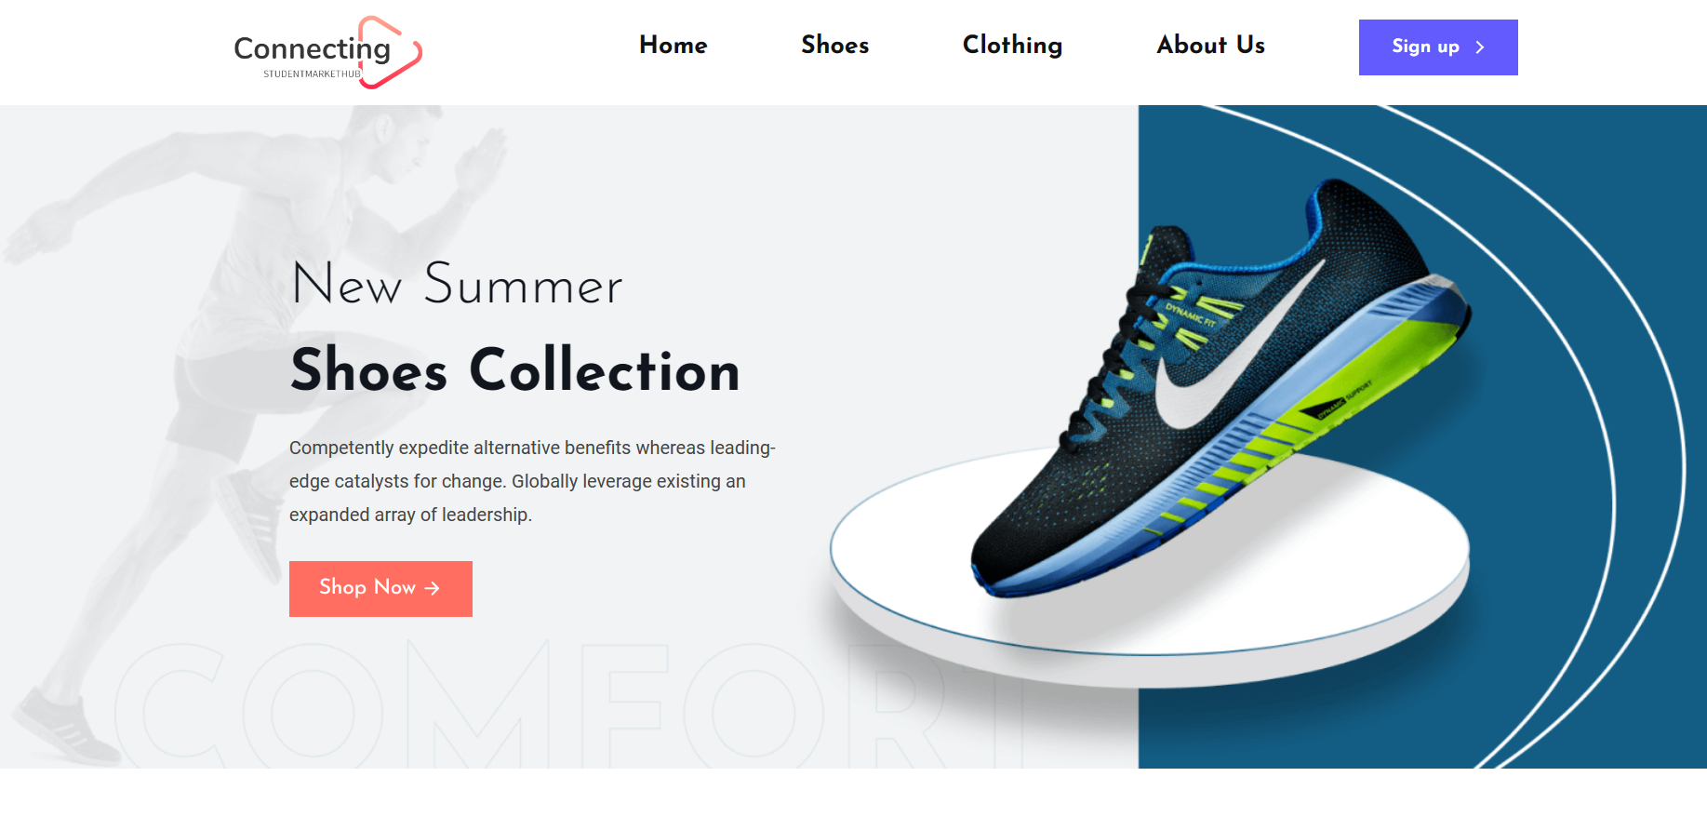

**Shoes**

Discover a wide range of footwear options to suit every style and occasion, from sneakers to formal shoes.



**Watches**

Stay on time and in style with our selection of watches, ranging from classic designs to modern smartwatches.

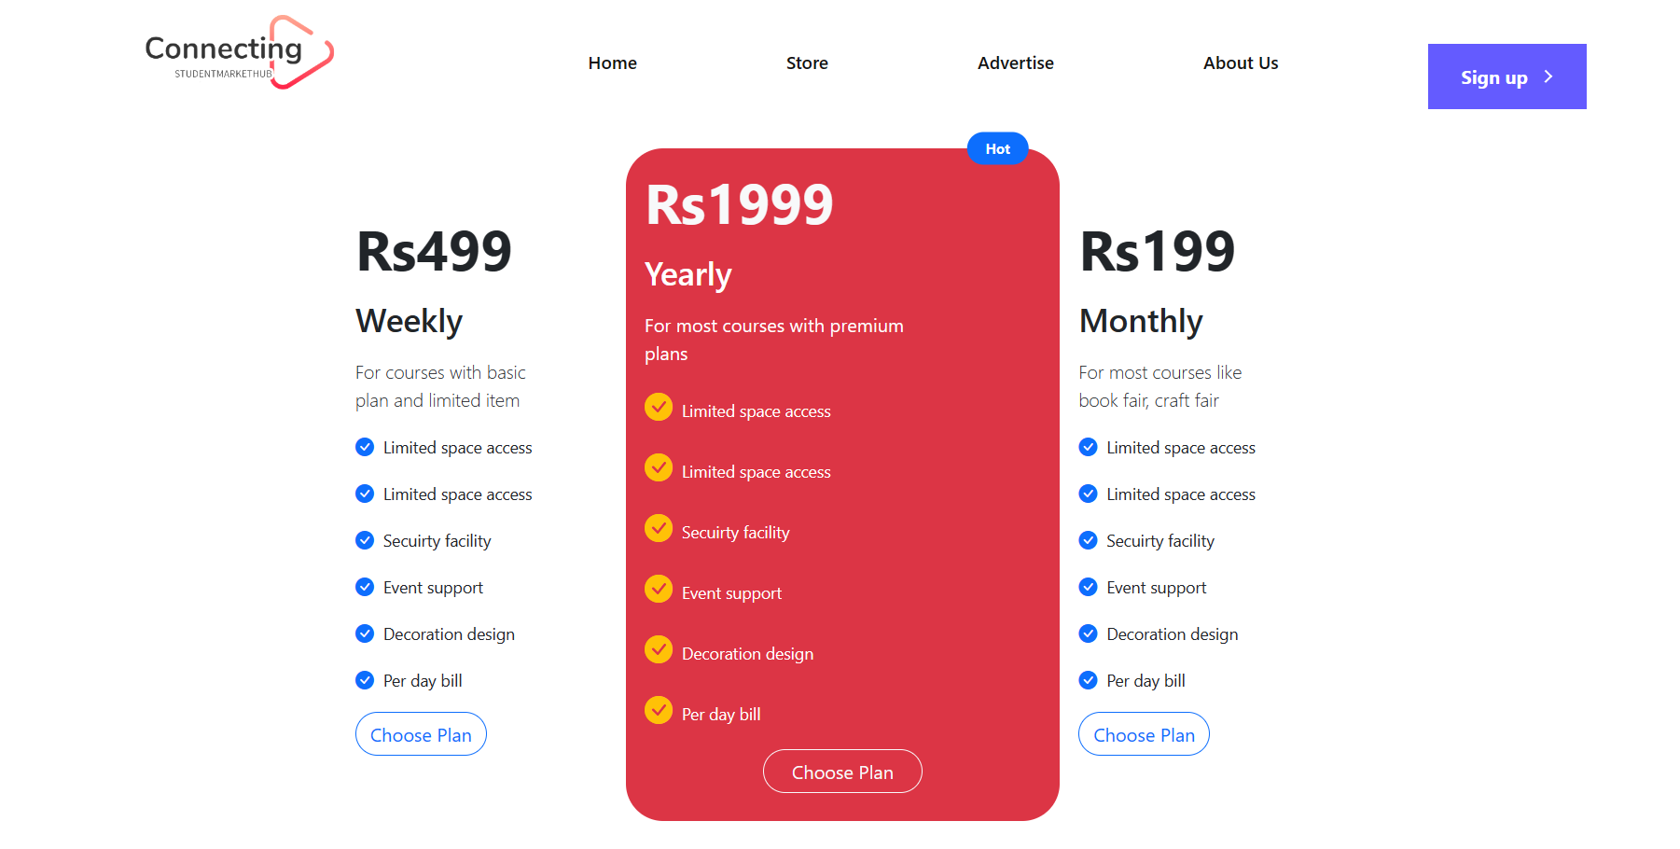

**Advertisement**

**Boost Your Sales**

Reach a diverse audience of college students and promote your products through personalized advertisements.

**Special Offers** – Yearly , Monthly and Weekly packages

Expand your reach and establish a strong presence in the college market with targeted advertising campaigns

**Increase Brand Visibility**

Stand out from competitors and create brand recognition among college students with eye-catching ads

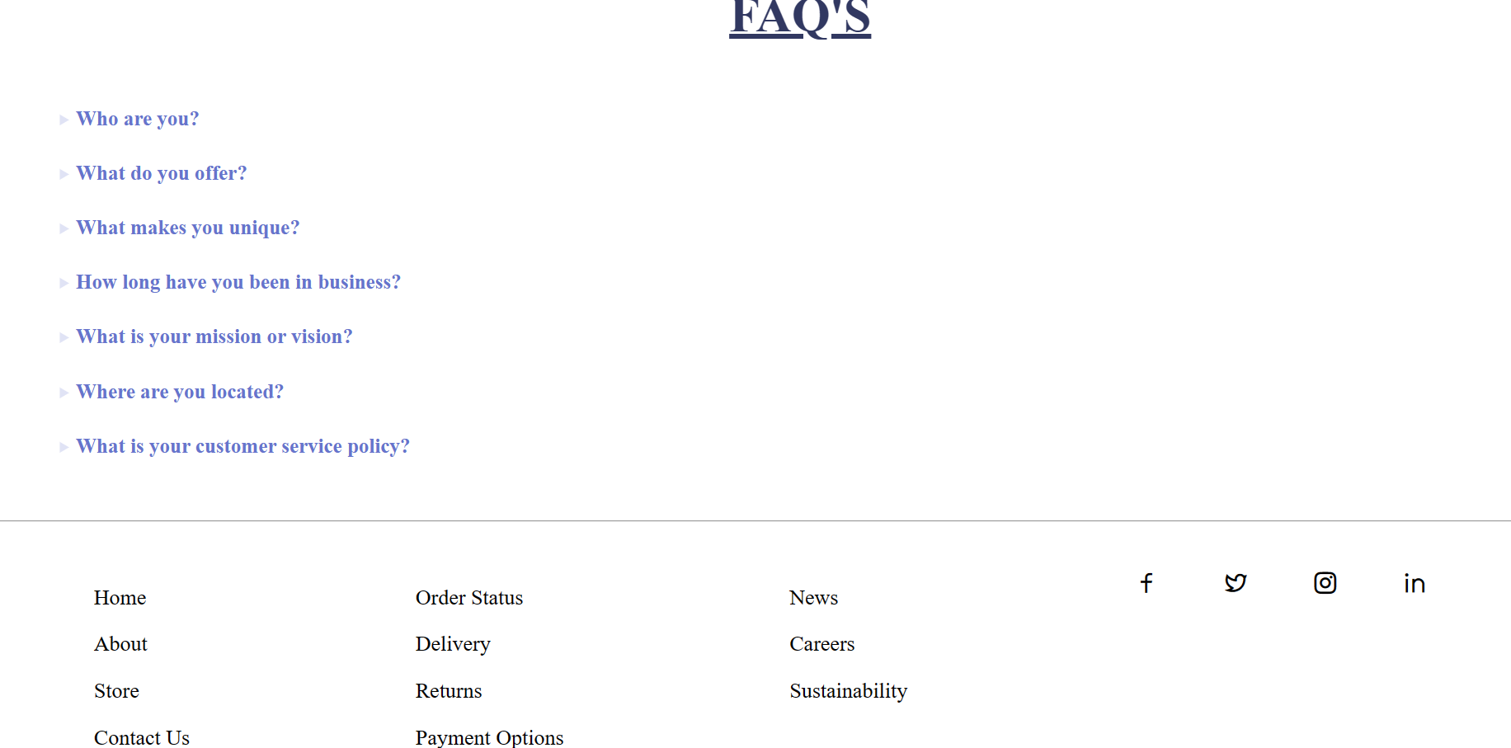

**Contact Us**

Have a question, feedback, or need assistance? Our dedicated team is available to assist you. Get in touch with us today!

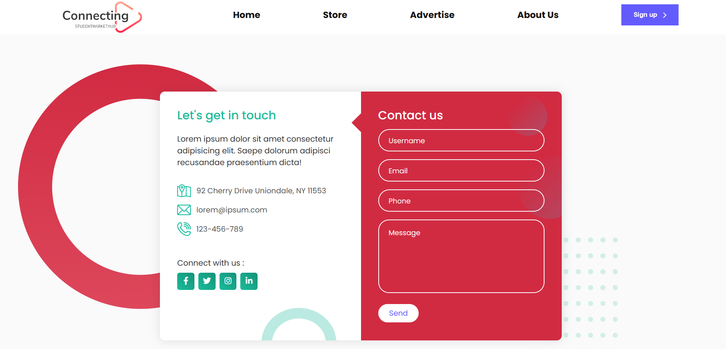

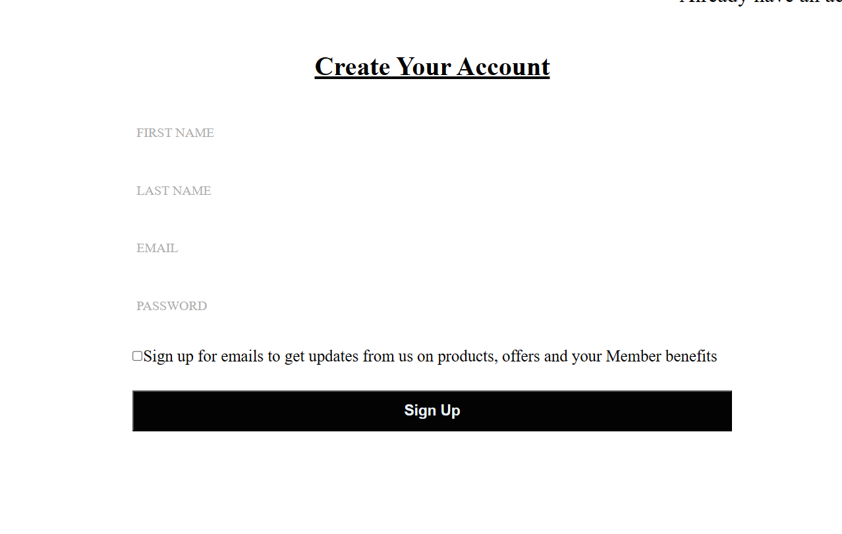

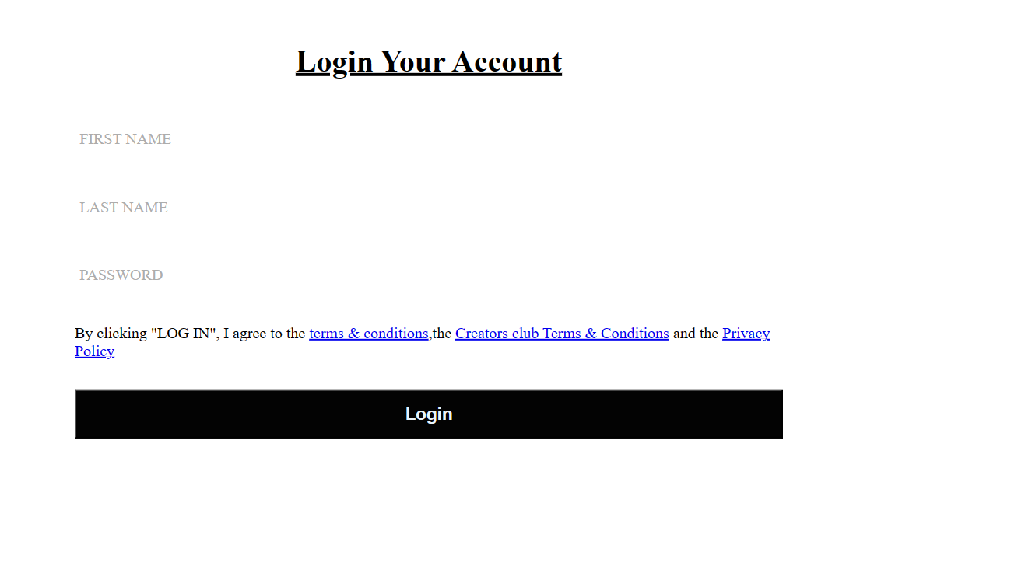

**Sign Up**

**Create an Account**

Join our community by creating a personalized account to access exclusive features and benefits.

**Save Your Preferences**

Customize your shopping experience by saving your preferences and receiving personalized recommendations

**Keep Track of Orders**

Track your orders, manage your wishlist, and have easy access to your purchase history.

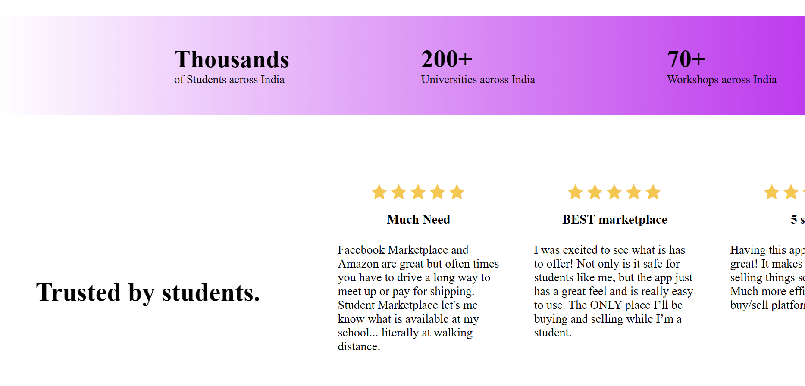

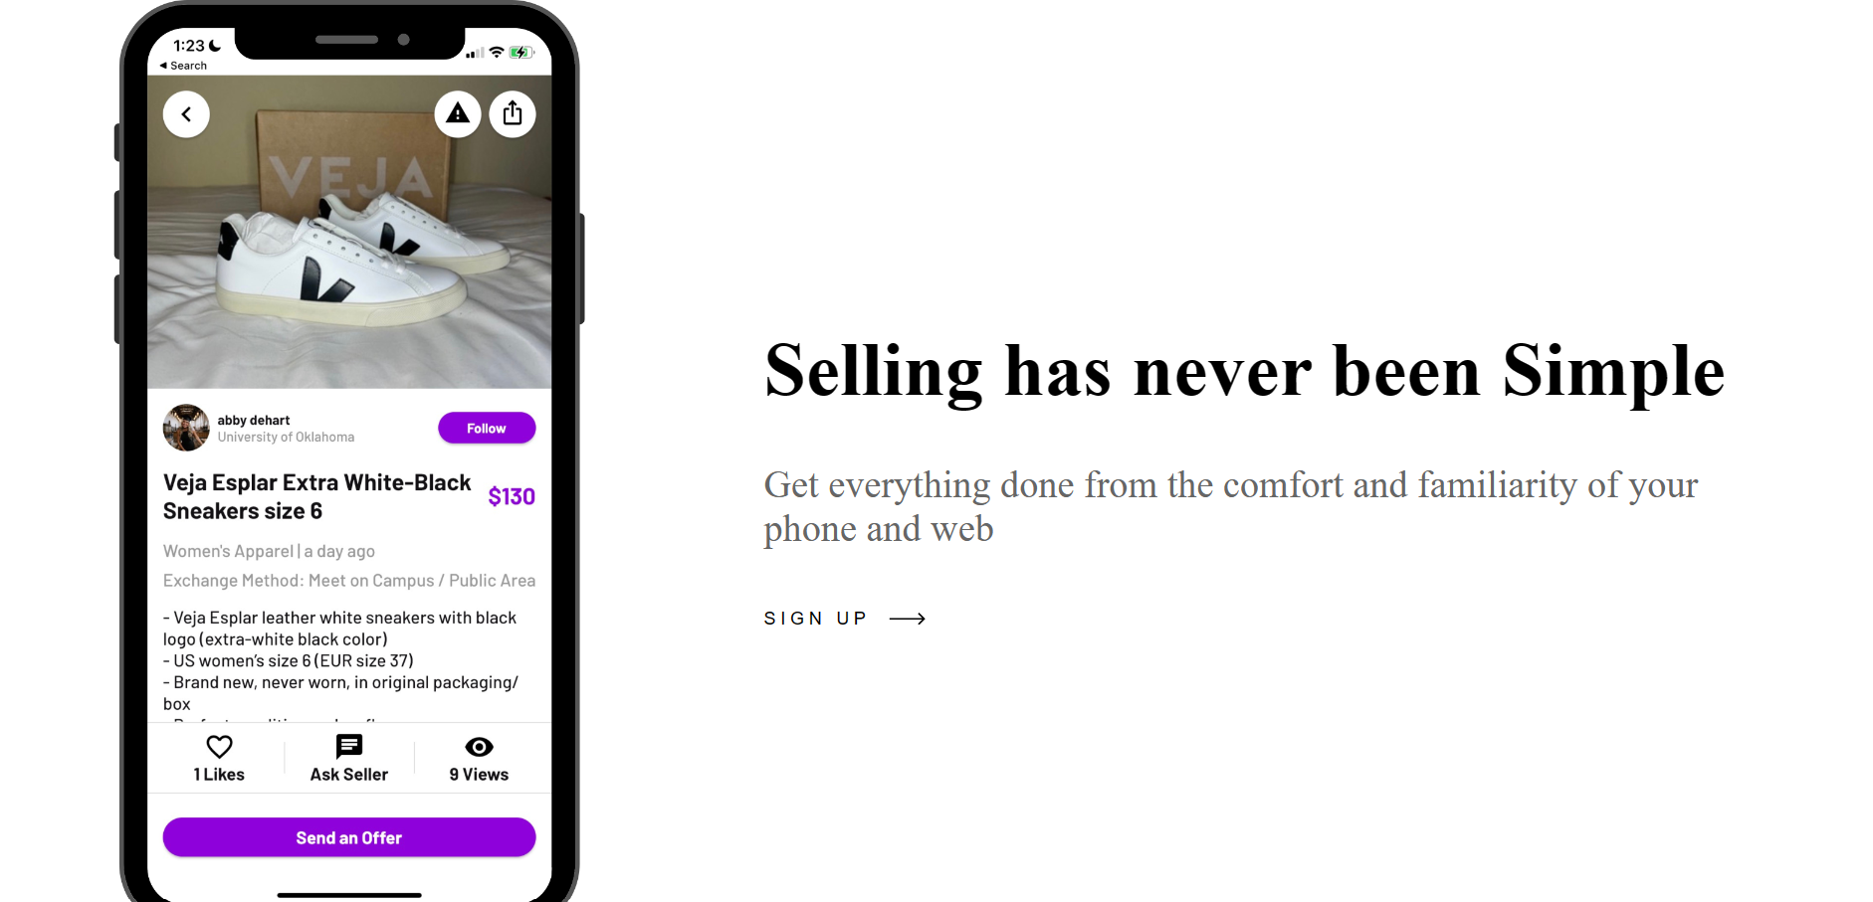



**Book Hub**

Find all the textbooks and e-books you need for your courses, conveniently sorted by subject and title.

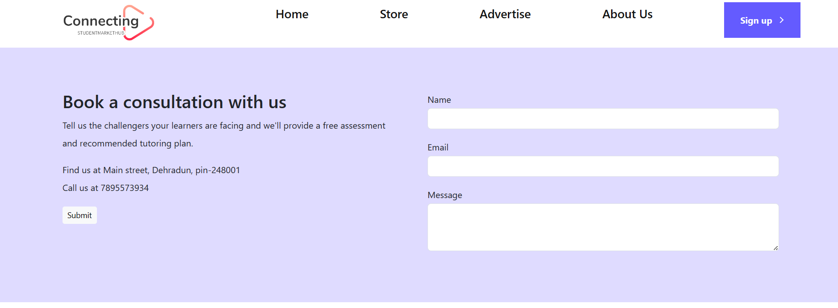

**Payment**

**Secure Online Payment**

Enjoy peace of mind knowing that your transactions are protected with advanced security measures.

**Accepted Payment Methods**

Choose from a variety of payment options, including credit cards, digital wallets, and more.

**Order Confirmation**

Receive instant confirmation and detailed order summaries for every purchase.